*Heaven’s light is our guide.*

****Rajshahi University of Engineering and Technology**

**

**Department of Electrical & Electronic Engineering**

**Course no.** EEE 4166

**Course title:** Processing & Fabrication Technology Sessional

**Experiment no.** 3

**Experiment name:** Experimental study of thin flim deposition technique using Sol- gel method

**Date of experiment:** June 14, 2023

**Date of submission:** July 12, 2023

|  |  |
| --- | --- |
| **Submitted to:** | **Submitted by:** |
| **Dr. Md. Faruk Hossain**  **Professor**  Dept. of Electrical & Electronic Engineering,  Rajshahi University of Engineering and Technology. | **Ashraf Al- Khalique**  **Roll:** 1801171  **Session:** 2018-2019  Dept. of Electrical & Electronic Engineering,  Rajshahi University of Engineering and Technology. |

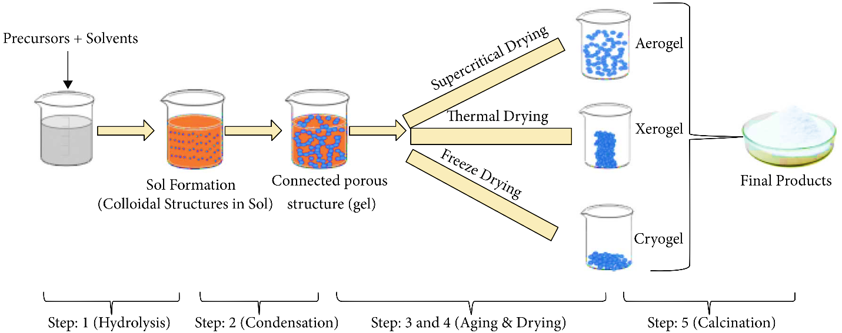

**Fig. 3.1:** thin flim deposition technique using Sol- gel method